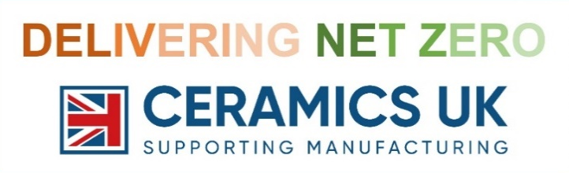
Tues 17th Sept 2024
Staffs University, The Catalyst
Leek Rd, Stoke-on-Trent, ST4 2DF
until 31st MAY: £155 | Price THEREAFTER: £175
Includes refreshments throughout the day and on-site parking. Spaces can be booked provisionally at the early bird rate, with names confirmed later. Price per person and excludes VAT.

Please complete & return booking form to: helenc@ceramics-uk.org

Contact name: |  | E-mail:
Organisation:
Invoice address:
Invoice e-mail: |  | Order No. (if required):
No. of attendees: |  | Telephone:
Sponsorship package (see below options):
NB: cancellations before 31st Aug will be refunded 50%, with cancellations from 1st Sept charged in full.

Please provide name(s) of attendees (add further rows if necessary)

Name | Job title | E-mail address

NB: any personal data provided for the booking process will be processed in line with the Ceramics UK’s Privacy Policy under a ‘legitimate interests’ legal basis.
SPONSORSHIP / exhibiting PACKAGES:
Option: | Cost: | Details:
Full event sponsor | £1,499 | Lead-up: Feature on regular event comms (incl. ‘sponsor spotlight’). On day: Attendance for 2. Exhibiting space. Pop-up banner space by main stage. Promotion in event / social media.  After: One-page advertisement / article in post-event summary.
Exhibit & attend | £399 | Attendance for one, exhibit space (pop-up banner/s, table provided).
Special recognition award sponsor | £299 | Lead-up: named on award communications  On day: award presentation ceremony / photographs

NB: prices exclude VAT. If you’d like to discuss multiple packages, or other opportunities for potential collaboration, then please contact Lee Brownsword.

